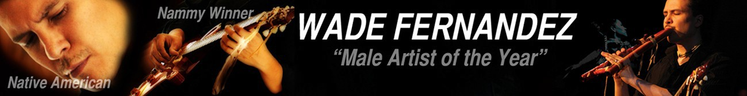

Soaring around the world with Menominee Indian Reservation roots, Wade Fernandez / Wiciwen Apis-Mahwaew (Walks With The Black Wolf) is a “deeply authentic” multi-award winning international touring artist and educator from the Menominee Nation. Winning numerous awards in multiple genres, Fernandez's musical style knows no bounds & the same goes for his educational style. Beginning his solo music career joining Jackson Browne & the Indigo Girls onstage has led to a long career with over 70 international tours rocking and soothing stages from Woodstock 94 to the Kennedy Center. His music and his message are firmly grounded in his Menominee Reservation roots and love for the land, animals, and people. A passion to educate, share music, serve community, share culture and honor Grandmother Earth is reflected in Wade's global presentations, speaking events, work with schools (k-college), workshops, serving the elderly, the mentally disabled, the incarcerated, and the youth. Wade is equally adept live on location as he is for livestreaming.

www.WadeFernandez.com info@wadefernandez.com
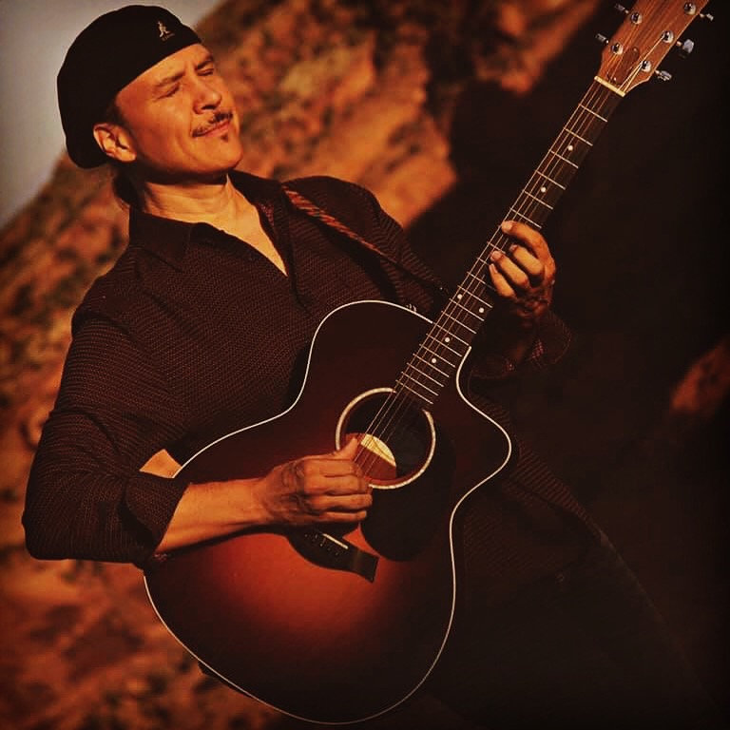
Sample Of Musical Performances
Woodstock ’94, Reebok Human Rights Awards (2002 Winter Olympics), Ed McMahon’s Next Big Star, Chicago’s World Music Festival, The Kennedy Center in DC, Germany’s Tollwood Festival, and well over 70 international tours.
Performed with Jackson Browne, The Indigo Girls, Jeff Cook (Alabama), Chuck Leavell (The Rolling Stones). Shared stages with dignitaries such as Robert Redford & Bishop Desmond Tutu.
Sample Of Commissions Native Radio Theatre, Milwaukee Choral Artists, Menominee Casino, Tobacco Cessation project, Potawatomi Gathering theme song, various movie and television soundtracks for PBS, BBC, independent films.
Acting Native Radio Theatre, Theatre Of Color at University Wisconsin-Milwaukee
Sample of Teaching Arts; Marquette University Adjunct Instructor HIST/EPP 4155, Pop Akademie of Music in Mannheim, Rhinelander School Of The Arts, numerous artist residencies, presentations and workshops in U.S. & Europe teaching Native American History & Culture, Native American Flute, Songwriting, Guitar, Artist Trainer for First Peoples Fund, etc. Works internationally with kindergarten-college and beyond.
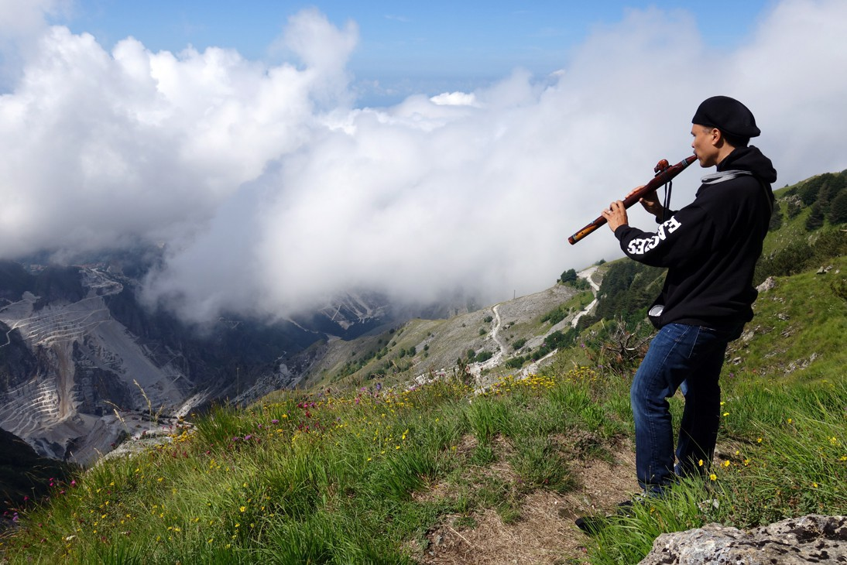

“ …an artist in his own right who deserves to be heard on his own terms”

Peter Buffet – Emmy Award winning producer
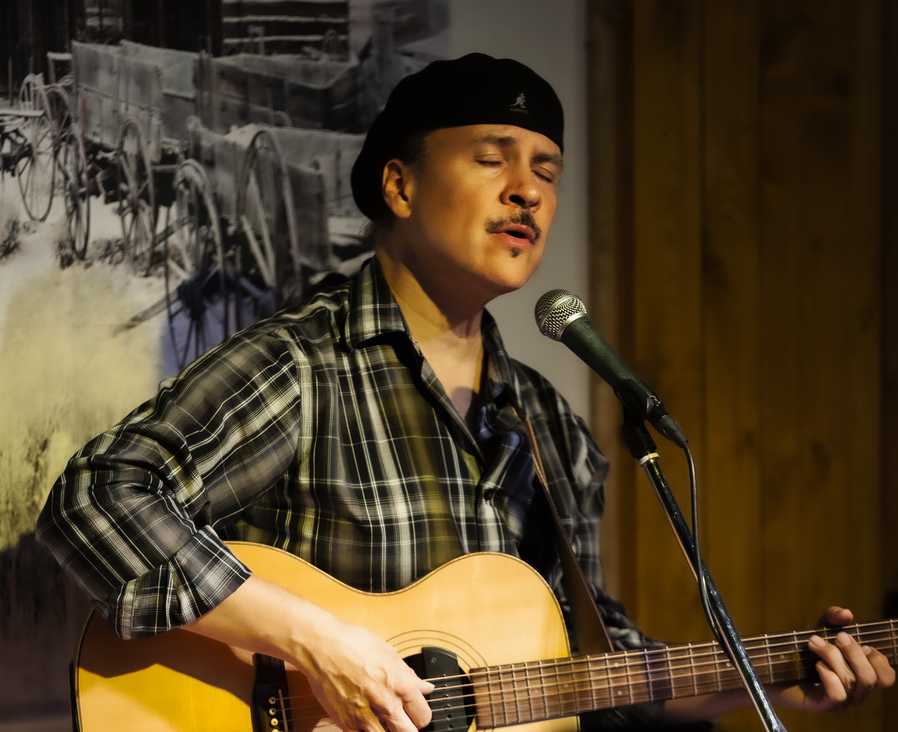
Sample of Awards & Honors
2021 | President's Community Engagement Award from Medical College Of Wisconsin
2019 | Artist Of The Year, Flutist of the Year, Best Instrumental Recording finalist NAMMYs
2017 | Best Blues award winner from ISMA's & finalist 5 categories/genres including Native Flute
2016 | Guitarist of the Year finalist WAMIs
2014 | Artist Of The Year & Album Of The Year finalist from NAMMYs
2013 | Folk and Pop Songs of the Year winner from ISMAs
 | Rock, Blues & Country finalist recording of the year.
2010 | Community Spirit Award winner -First Peoples Fund
2007 | Contemporary Instrumental & Best Country ISMA winner
 | finalist for Best Blues, Pop, Classic Rock, Native Flute
 | Artist of the Year & Pop/Rock finalist NAMMYs
2006 | Best Male Artist winner (finalist Pop/Rock & Best Music Video) NAMMYs
2005 | Best Music Video at Indian Summer Film & Video Awards
 | Best Music Video Cherokee International Film Festival
2002 | Best Blues/Jazz, Male Artist of the Year, Songwriter of the Year finalist
2001 | “Storyteller/Writer of the Year” (CD category) from Wordcraft Warriors
1997 | Tomorrow's Leaders Today Award (Milwaukee, WI)
1996 | Dean's Award of Excellence (UW-Milwaukee)
1995 | Medal of Honor from Menominee Indian Nation

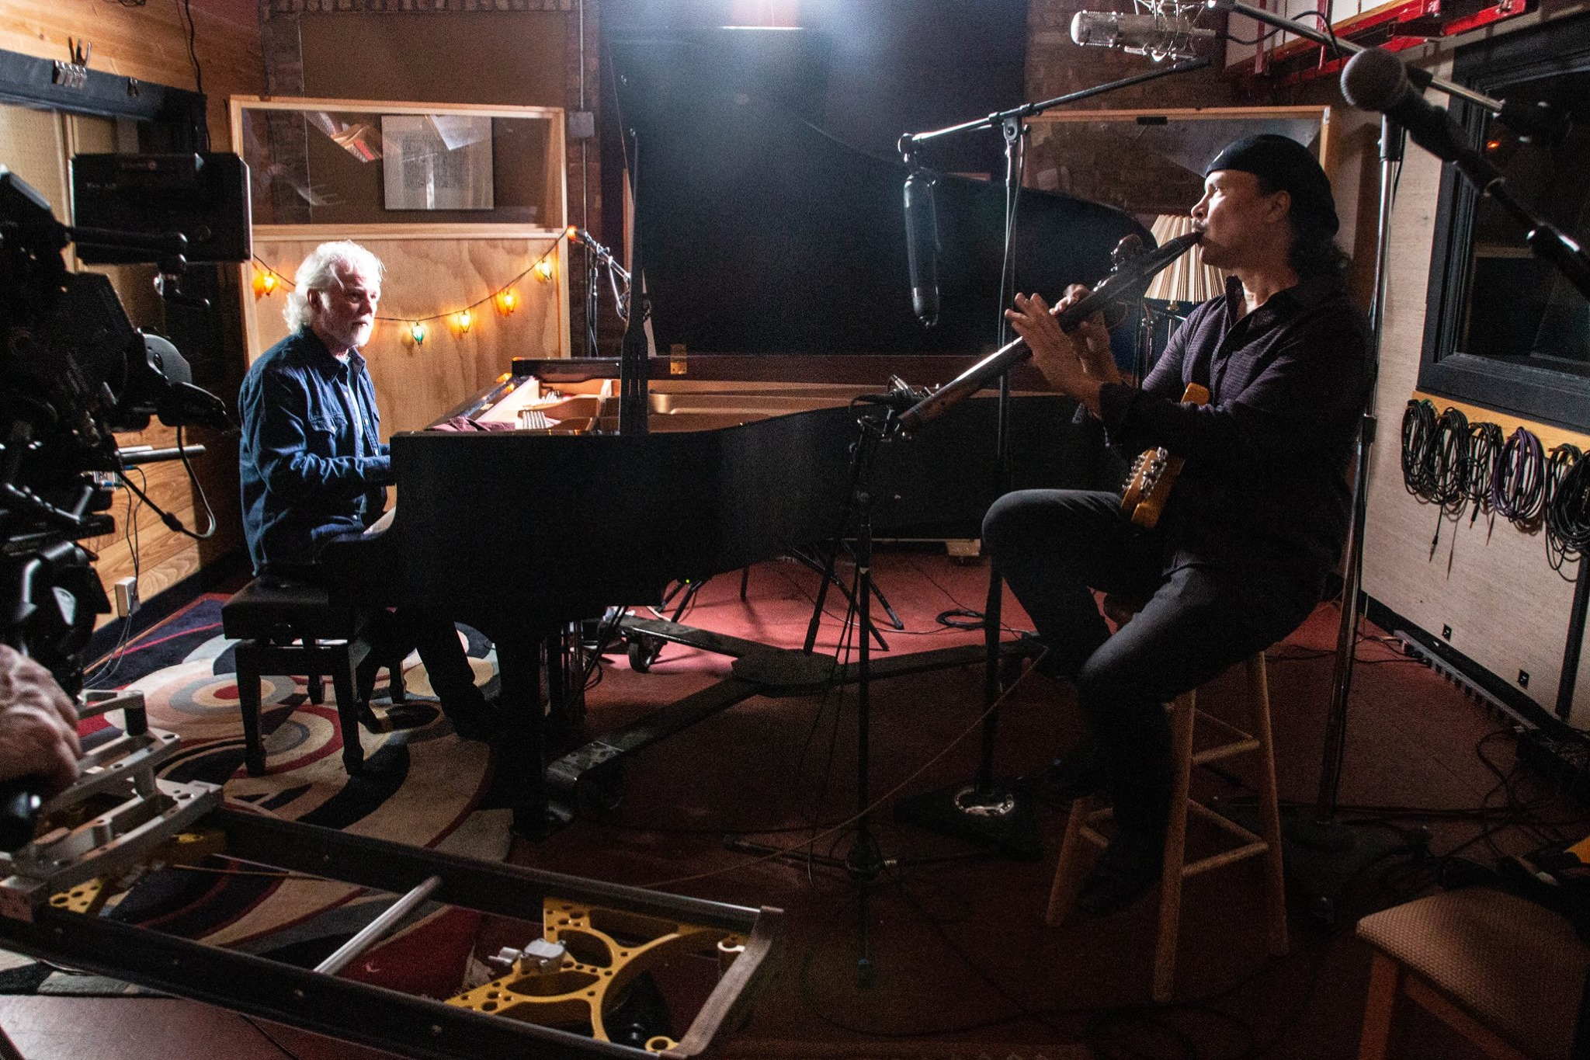
On set PBS documentary with Chuck Leavell from The Rolling Stones

PRESS &QUOTES For Both Music & Education

“World class.. Phenomenal.. hard to forget after one listen..a unique style as both a musician and songwriter …blessed with talent that can’t be learned, and with a gracious and inspiring soul that can’t be tainted by the pitfalls of the music industry.” Indian Country Today

“what beauty and respect you brought to all of us fortunate to have been in your presence. We were honored and blessed, and forever changed.”

Sharon A. Hansen, Music Director The Milwaukee Choral Artists

“.. an artistic and spiritual force that has just begun to gather steam.”

The Massachusetts Daily Collegian

“Speaks to the heart of all native people.. Your jam session with Jackson Browne was phenomenal.”

Oneida Nation Arts Program
“Soaring beyond the invisible culture of the corporate music industry.” Vital Source

“guitar and songwriting skills are incredibly sharp, …remarkable in range, quality and sincerity.. soars with beauty and power.” Post Gazette

“To see a male role model who has learned to celebrate traditional knowledge (particularly through story) and integrate that wisdom in a music performance context is profound. Through your life we can celebrate and reaffirm our lives. You're a gem. Thank you for gracing us with your gifts.”
Sheila Rocha, PhD, Institute for American Indian Arts in Santa Fe, NM

"Wade Fernandez is not only a world-renowned musician, but an incredibly gifted teacher. And I'm not just talking about music, but also history, and Menominee culture and language. I have had the pleasure to co-teach with Wade for going on two years, and have been humbled by his teaching style and substance time and again. I cannot even begin to describe how important Wade is as an educator, because so much of his life and reputation is tied to his music, but please know that Wade is hands-down an incredible leader and role model inside and outside the classroom."
Dr. Bryan Rindfleisch, Associate Professor of History, Marquette University

“All that one would think was lost with the great guitar legends of the early-twentieth century are now alive and touring with Wade Fernandez and his band the Black Wolf Group. The Leader
“able to transcend all cultural stylistic and technical boundaries to communicate a powerful message” Strandgut (Frankfurt, Germany)
“..surprising diversity... swings effortlessly from blues, folk-rock, flamenco and jazz, with traditional singing and drumming… a sincerity and integrity which is reflected not only in his lyrics but in his expressive use of guitar...” Indigenous Links (London, England)

“Wade Fernandez is an incredibly talented performer, motivational speaker and instructor with the special ability to connect with and inspire others. He is also a gifted teacher who brings out the best in everyone.” Lynn Tarnoff, MA, Director, School of the Arts Rhinelander, UW-Madison

“..an accomplished musician/composer/producer/engineer/guitarist with spicy chops, that deliver a beautiful performance, live, filmed or recorded!! He is a wonderful teacher/father/husband that works very closely with the youth from his reservation. … labor of love for the people and tradition on a profound level… clever, patient and inspirational, with the youth… a community spirit man and a professional artist that has a beautiful show and message!” Pura Fe

“Wade Fernandez is more than an extremely accomplished musician, a superb songwriter and a great performer, his house concert with us was like being held spellbound by a close friend who told stories, played wonderfully evocative melodies and sang songs that gave an insight into the Native American culture of the Menominee tribe. It was a bridge to an ancient history, yet it was as relevant and contemporary as some of the best song writing coming out of America today; a bridge that also crossed over into our own Celtic culture, history and music. It was, quite simply, a wonder shared."
Tom Fairnie Show (Radio Saltire), Scotland

“You speak and play from a place deep within you that reaches all of us in a truly extraordinary way. My students spoke rapturously about their time with you as being transformative and profound, about all of the wise insights that they had learned from you, and reflecting on how to bring those into their own lives.”
Karen Hoffmann, Assoc. Professor of English, Lawrence University

“Wade Fernandez is phenomenal in a classroom. From pre-K to graduate students, Wade always finds the perfect combination of performance, story-telling, and teaching that will resonate most deeply with his audience. His visits to our classrooms at Lawrence have helped our students see, and hear the world in whole new ways. I can’t recommend him highly enough. His most recent visit was over Zoom and it was just as powerful as his in-person visits.”
Brian G. Pertl, Dean, Lawrence Conservatory of Music

Wade Fernandez engages students in the Menominee culture, singing, dancing, and storytelling through his exceptional musicianship and cultural knowledge. My students are captivated and enthralled during his presentations and he is able to manage them in such a way that they all stay incredibly focused. Students love singing songs in the Menominee Language and listen to every word. Students with special needs take to him as he can inspire them in ways that others can not. I would highly recommend him for any school.
Mr. Craig Pynenberg, Hillcrest Primary Music School Teacher, Shawano, WI

“Wade did a fantastic job with our students Pre K through 8th grades. Not only did he teach about music and his life as a musician, he shared information about growing up on a reservation, values, goal setting, overcoming obstacles and more. He was able to have age appropriate conversations with each class. I know he positively impacted every person who got to interact with him. This program exceeded any expectations!”
Fort Atkinson Catholic School

“Wade is an absolute pleasure to work with! I have hosted him a number of times over the past years to do four day residencies with my 4th graders. He has such a kindness and calmness about him that comes through in all his interactions with students and adults. Wade easily establishes a rapport with students and teaches life lessons right along with lessons about his Menominee culture. My classes are always excited to work with him and can’t wait to see what they will learn next. Wade’s passion for teaching and learning is inspiring! He is always willing to work with me, be flexible when needed in the schedule, and is very respectful with everyone he interacts with. The lessons Wade teaches my students will be something they will carry with them throughout the rest of their lives. Thank you Wade for having such a lasting positive impact on my students!”
Jodi Prien, 4th Grade Teacher, Suamico Elementary School

Educational Offerings

With Menominee Nation roots extending back to the Ice Age in the land that is now called Wisconsin/Upper Michigan, Wade Fernandez, Wiciwen Apis-Mahwaew (Walks With The Black Wolf), has been sharing his musical art and Menominee culture on stages and classrooms worldwide for over 30 years. When not on tour, Wade lives among the pristine ancient forestland on the Menominee Reservation with his family where he strives to live in a respectful, honorable, and sustainable way. Wade is an international award winning musician/recording artist/songwriter/producer who tours with voice, guitar, Native American flute, and hand drum. As a certified teacher with extensive educational experience in classroom, onstage, and in parenting (proud father of 5), Wade combines a wealth of experience, a warm personality, and a sense of humor that has kept students and audiences repeatedly inviting him back year after year.

Performance & Residency Information
Wade has extensive experience working with all age groups (k-12, college, and elders) and all programs may be altered to fit any age group.

Finding Your Voice Through The Native American Flute (Grade 5-elderly, multi-day residency)
The Native American Flute is a therapeutic instrument that helps one to deeply express their emotions and innate music. Students learn how to play and improvise on the Native American Flute. No previous musical experience is necessary. This is usually a 4 day residency that culminates at the end of the week with students performing a concert with Wade for school and/or community. With the concert at the end, students apply and share their newfound talents and build self-esteem. Please note there are usually extra fees for flute purchase or rental, so please inquire directly.

Menominee Culture, Storytelling, Music, History, (Grades K-adult)
Music Workshop
Erasing Stereotypes Through Arts & Culture (Grades K-adult)

School Performance/Motivational Speaking
Wade is an award winning international touring contemporary American Indian performing artist and is available for concerts at your school. His school performances provide music, motivational speaking, environmental awareness, etc. Through music, words, and actions Wade motivates students to recognize and honor their gift of life and talents by developing and sharing them with others while on their pathway to a successful and healthy future.

